Speaker 1: Monisha Gosh

Title: A New Paradigm: Mid-Band Sharing-Native 6G

Bio: Monisha Ghosh is a Professor of Electrical Engineering at the University of Notre Dame. She is also the Policy Outreach Director for SpectrumX, the first NSF Center for Spectrum Innovation and the co-chair of the FCC’s Technological Advisory Council (TAC) Working Group on Advanced Spectrum Sharing. Her research interests are in the development of next generation wireless systems: cellular, Wi-Fi and IoT, with an emphasis on spectrum sharing and coexistence. Prior to joining the University of Notre Dame in 2022, she was the Chief Technology Officer at the Federal Communications Commission, a Program Director at the National Science Foundation, Research Professor at the University of Chicago and spent 24 years in industry research at Bell Labs, Philips Research and Interdigital working on a wide variety of wireless systems: HDTV, Wi-Fi, TV White Spaces and cellular. She obtained her B.Tech from IIT Kharagpur in 1986 and Ph.D. from USC in 1991. She is a Fellow of the IEEE.

Speaker 2: Le Liu

Presentation Title: 6G visions and standardization activities

Bio: Le Liu joined Qualcomm in 2017, where she has been working on 4G/5G standardization. Besides participation as a RAN1 Qualcomm delegate, she has been contributing to the design and development of LTE MTC/NB-IoT, SRS enhancement, and 5G NR (New Radio) RedCap, multicast/broadcast, UAV, NTN, narrowband private network, ambient IoT, etc.. Recently, she has been working on 6G design on control and power saving, initial access, etc.. Le Liu received Ph.D. degree in electrical engineering from the Tohoku University, Japan.

Speaker 3: Bo Goransson

Title: 6G standardization: What’s in it for radio

**Bo Göransson**received his M.Sc. degree in applied physics and electrical engineering from Linköping University, Sweden, in 1991, and the Ph.D. degree in array signal processing from the KTH Royal Institute of Technology, Stockholm, Sweden, in 1997. He joined Ericsson Research in 1998, where he has been working with research and standardization of 3G, 4G, and 5G physical layer with special interest for MIMO and beamforming technologies. From 2008 he has been with the Standards & Technology department, a research group within business unit networks where he worked on 4G and 5G testbeds. During this time he was also involved in standardizing OTA radio requirements for antenna integrated radio systems. He is currently a Senior Expert in multi antenna systems and architectures with Ericsson and an Adjunct Professor with the KTH Royal Institute of Technology. He holds more than 200 patents (issued and pending). He received the Ericsson Inventor of the Year Award in 2012. His research interest is to understand a massive MIMO system from the physical layer all the way to radiated RF.

Speaker 4: Andreas Roessler

Title: Towards AI-native air interface for 6G: Machine Learning-based Channel State Information (CSI) feedback enhancements in 5G-Advanced  
  
Bio : Andreas Roessler is working as a Technology Manager for Rohde & Schwarz, a premium supplier of test and measurement solutions to the wireless industry, headquartered in Munich, Germany. As a technology manager, he focuses on 3GPP’s 5G New Radio (NR) standard and advancing 6G research topics.

His responsibilities include strategic marketing and product portfolio development for the entire value chain offered by Rohde & Schwarz test and measurement division. By following industry trends and the standardisation process for cellular communication standards very carefully, he gained more than 15 years of experience in the mobile industry and wireless technologies. He holds an MSc in electrical engineering with a focus on wireless communication.

Speaker 5: Russell Ford

Presentation Title: 6G: Future Wireless for the AI Era

Bio: Dr. Russell Ford is a Staff Research Engineer with Samsung Research America in Mountain View, CA. As a member of Samsung’s Standards and Mobility Innovation (SMI) Team, his research focuses on the intersection of AI/ML and wireless networks. Recently, his work includes developing advanced algorithms and proof-of-concept systems to validate the real-world performance of AI for PHY-layer enhancement, as well as for network analytics and automation. Russell received his M.S. in electrical engineering and Ph.D. in computer science from New York University in 2012 and 2017, respectively.

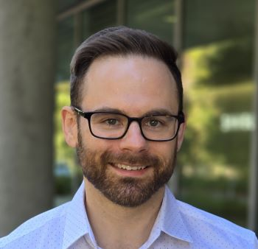

Speaker 6: Nick Sutardja

Title : AI for RF SoC Optimization

Dr. Nick Sutardja is the Co-Founder & CEO of Danger Devices Inc, a next-gen, fabless semiconductor company, tackling the RF Front End space. He’s taped out over 50 unique CMOS chips in various process technology nodes.

Dr. Sutardja holds a Ph.D in Integrated Circuits, BS EECS, and BA in Applied Mathematics from the University of California, Berkeley. Dr. Sutardja also has several publications and patents in the field of electronics.

Speaker 7: Xingqin Lin

Talk title: The Interplay between Artificial Intelligence and 5G-Advanced toward 6G

Biography: Xingqin Lin is the 3GPP Lead at NVIDIA, spearheading 3GPP and ATIS standardization and conducting research at the intersection of 5G/6G and AI. Before joining NVIDIA, he was with Ericsson, leading 5G/6G research and standardization in focus areas. He was an Ericsson NextGen Advisory Board member, collaborating with Ericsson Executive Team on strategic projects. He is an expert in wireless communications and technology strategy and a key contributor to 5G NR, NB-IoT, and LTE standards. He served as the founding co-chair of the ATIS AI Network Applications working group (2023-2025). His pioneering work has led to strategic opportunities, products, and real-world deployments in the telecom industry, enabling major network transitions from 4G to 5G.

He is co-author of the book “Wireless Communications and Networking for Unmanned Aerial Vehicles” and the lead editor of the books “5G and Beyond: Fundamentals and Standards” and "Fundamentals of 6G Communications and Networking." He has published 100+ refereed papers and contributed to 200+ patent applications, including standards essential inventions. His publications have been cited over 10,000 times.  He has garnered several awards, including the IEEE Communications Society Fred W. Ellersick Prize (2021), IEEE Vehicular Technology Society Early Career Award (2021), IEEE WCNC Best Paper Award (2020), and IEEE Communications Society Best Young Professional Award in Industry (2020), among others.

He serves/served as an editor of the IEEE Communications Letters (2015-2018), IEEE Network (2021-2024), IEEE Internet of Things Magazine (2021-now), IEEE Communications Magazine (2022-now), and IEEE Communications Standards Magazine (2024-now), the lead guest editor for the IEEE Network special issue on "The Interplay Between Generative AI and 5G-Advanced toward 6G" and IEEE Communications Magazine special issue on “Digital Twins Meet Artificial Intelligence in 6G," and the lead editor for the IEEE Internet of Things Magazine series on "AI for IoT." He was recognized as an exemplary editor of the IEEE Internet of Things Magazine (2021 & 2022 & 2013) and IEEE Network (2022). He is an IET Fellow, an IEEE ComSoc Distinguished Lecturer (2024-2025), and an IEEE VTS Distinguished Lecturer (2024-2026). He holds a Ph.D. in electrical and computer engineering from The University of Texas at Austin, USA.

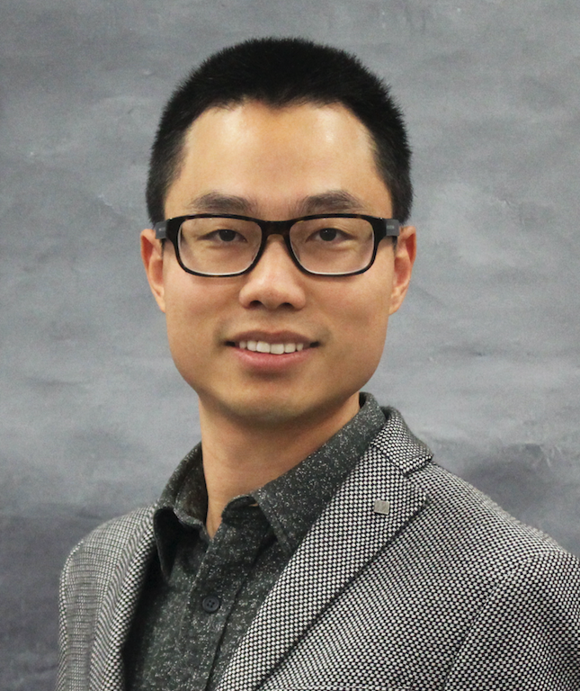

Speaker 8: Jeff Walling

Title: Digital-Friendly CMOS Flexible for the Next-G

Speaker Bio: Jeff Walling received his BS from University of South Florida and his MS and PhD

from University of Washington, all in Electrical Engineering. He has held industrial positions at

Motorola, Intel, Qualcomm and Skyworks. His research has primarily focused on circuits

for wireless communications and sensing. From 2012 to 2019, he was an assistant, then

associate professor at University of Utah. Then he was head of RF transceivers at Tyndall

National Institute in Cork, Ireland. Since 2021, he is an associate professor at Virginia Tech. He

has served as an associate editor for TCAS-II, TCAS-I and JSSC, and on the technical program

committees of the IEEE RFIC, ISSCC and NEWCAS conferences. In 2025, he was the North

American Regional Subcommittee Chair for ISSCC. He is a senior member of the IEEE and has

more than 100 papers in peer reviewed conferences and journals.

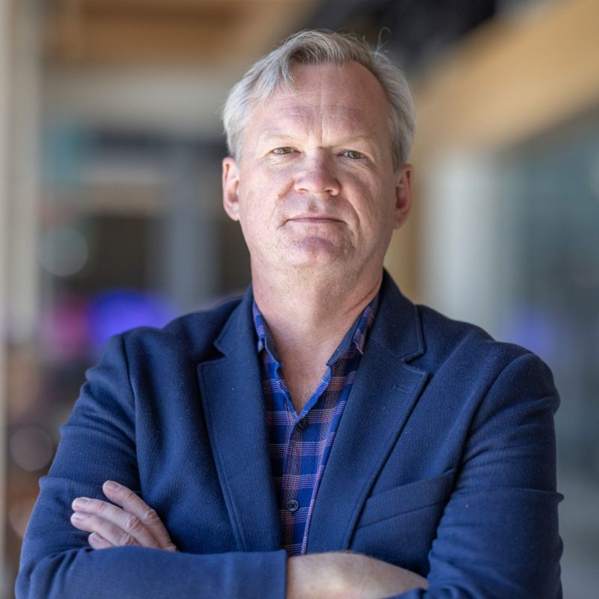

Speaker 9: Shahriar Shahramian

Titel : 6G Network Technologies, Systems & Architecture

Bio : *Shahriar Shahramian (SM ’06) received his Ph.D. degree from University of Toronto in 2010 where he focused on the design of mm-wave data converters and transceivers. Shahriar has been with the Bell Laboratories – Nokia since 2009 and is currently the Lab Leader (Director) of the RFIC & Packaging Research Lab. His research focus includes the design of mm-wave wireless and wireline integrated circuits and systems. Shahriar is a Bell Labs Fellow and leads the design and architecture of several state-of-the-art ASICs for optical coherent and wireless backhaul products. Shahriar has served as the chair mm-Wave & THz subcommittee of IEEE BCICTS & mm-Wave SoCs at IEEE RFIC and member of the technical program committee IEEE ISSCC. He has also served as the guest Editor of the IEEE Journal of Solid-State Circuits (JSSC).*

*Shahriar has been the recipient of Ontario Graduate Scholarship, University of Toronto Fellowship, and the best paper award at the CSICS Symposium in 2005, 2015 and RFIC Symposium in 2015, 2020, 2022 and ISSCC in 2018. Shahriar is also the recipient of the IEEE MTT Young Engineer Award in 2020. He holds an Adjunct Associate Professor position at Columbia University & Princeton University, has received several teaching awards and is the founder and host of The Signal Path educational video series. Shahriar has also presented short courses and workshops at the IEEE CSICS, BCTM, BCICTS, RFIC/IMS and ISSCC conferences.*

Speaker 10: Sang-June Park

Title: Next generation cellular radio system development

Bio: Dr. Sang-June Park received his Ph.D. in electrical engineering and computer science from University of Michigan, An Arbor, with a focus on electromagnetics and applied RF circuits. Dr. Park is currently at MediaTek USA, where he leads the Wireless System Design Group. He has over 20 years of experiences in the field, having previously worked at Samsung Electro-Mechanics for 4 years and Qualcomm for 15 years. His expertise includes cellular radio system development including FR2 mm-wave, RF antenna front-end design, and tunable system design. He is currently working on next gen cellular radio system, WiFi system, and high-speed wireless link design.

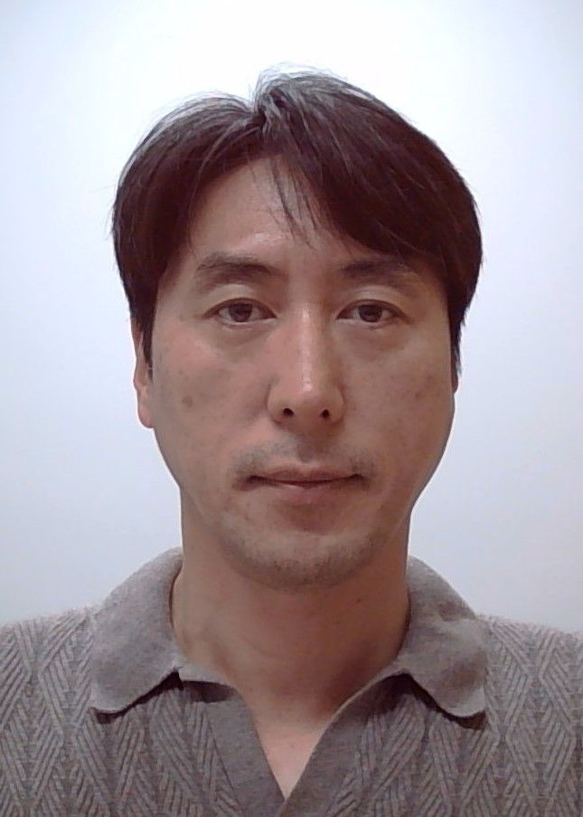

Speaker 11: Kaushik Sengupta

Title: AI-Enabled RF/mmWave IC Design  
Bio: Dr. Sengupta received his Ph.D. in Electrical Engineering from Caltech in 2012. Dr. Sengupta joined the Department of Electrical and Computer Engineering at Princeton University, Princeton, NJ, as a Faculty Member in 2013, where he is currently a Professor. His research interests include novel chip-scale architectures for intelligent sensing and communication for a wide range of emerging applications.  
  
Dr. Sengupta is an IEEE Fellow. He received the DARPA Young Faculty Award in 2018, the Bell Labs Prize in 2017, the Young Investigator Program Award from the ONR in 2017, the 2015 Microwave Prize, and multiple best paper awards in IEEE IMS and RFIC. He served as a Distinguished Lecturer for the IEEE Solid-State Circuits Society from 2019 to 2020 and for the IEEE Microwave Theory and Technology Society from 2021 to 2023. He is a recipient of the 2021 IEEE Microwave Theory and Technology Outstanding Young Engineer Award and the 2022 IEEE Solid-state Circuits New Frontier Award. He currently serves as the co-chair of the IEEE Solid-state Directions Sub-committee and as a technical advisor for the wireless start-up company, GuRu, based in Pasadena, CA. His group received IEEE Journal of Solid-State Circuits Best Paper of the Year in 2023.

Speaker 12: Jennifer Manner

The future of Direct to Device

Jennifer A. Manner is CEO of ZScientific, LLC.   Jennifer has significant experience in the domestic and international space, satellite, new technologies and spectrum policy arena. Jennifer recently served as a Senior Advisor at the U.S. National Telecommunications and Information Administration, Senior Vice President of Regulatory Affairs at EchoStar Corp., a global satellite operator where she was responsible for all policy and spectrum-related issues for the company.   Prior to EchoStar, Ms. Manner served at the Federal Communications Commission (FCC) as the Deputy Chief of the Office of Engineering and Technology and the Deputy Chief of the Public Safety and Homeland Security Bureau. Jennifer has also held senior positions at Skyterra, Inc. (now Ligado) and MCI/Worldcom (now Verizon), as well as Senior Counsel to FCC Commissioner Abernathy and as an associate at Akin, Gump, Strauss and Feld.

Ms. Manner has served in leadership roles at a number of trade association and federal advisory committees, including as President of the Satellite Industry Association, Chair of the Commerce Spectrum Management Advisory Committee, Vice Chair of the FCC World Radiocommunications Advisory Committee and Chair of the US ITU Association, among others.  Jennifer also holds leadership positions in international bodies such as the International Telecommunications Union (ITU), including as an editor of the Satellite Communications Technology Handbook and chairing sub working groups in preparation for and at World Radiocommunication Conferences, as well as a Chair of the Network of Women.

Ms. Manner has served as a professor at Georgetown University Law Center and at American University George Washington School of Law and guest teaches at the Silicon Flatirons Program at the University of Colorado Boulder and Carnegie Mellon University Executive Technology Program.

Ms. Manner is also an author and award-winning filmmaker. Ms. Manner has published numerous articles and books including Global Telecommunications Market Access (2003), Spectrum Wars (2005), Spectrum Wars: The Rise of 5G and Beyond (Artech House 2022) and Spectrum Wars: A New Hope for Connectivity (publication expected 2025). Ms. Manner’s films include Zebrafish: Practically People ([www.zebrafishfilm.org](http://www.zebrafishfilm.org/)) and When Wire Was King: The Transformation of Telecommunications ([www.whenwirewasking.com](http://www.whenwirewasking.com/)

Speaker 13: Gabriel Rebeiz

Title: Ku and Ka-band Low-Cost Phased-Arrays for LEO SATCOM Using Highly Integrated Silicon Beamformer Chipsets

Bio: Prof. Rebeiz is a Distinguished Professor and the Wireless Communications Industry Endowed Chair at UCSD. He is a member of the National Academy and is one of the fathers of tunable radios for 4G/5G, silicon beamformer RFICS and affordable phased arrays for satellites and 5G, and high-resolution automotive radars for collision avoidance. He has developed over 50 different radar and communication systems for both defense and commercial applications from 3 GHz to 100 GHz. Prof. Rebeiz won the IEEE MTT Prize three times, the IEEE AP John Krauss Antenna Award, the IEEE AP Wheeler Prize, and other high level IEEE Awards. Prof. Rebeiz graduated 125 PhD students and post-docs, including the former CEO of Qualcomm and several VPs in the communications and defense industry. He is the founder of Spectrabeam (sold to IDT/Renesas) and Extreme Waves, San Diego, CA.

