IMS2025 Student Design Competition   
Submission Form for the Organizers

# Title of your Student Design Competition

Power Amplifier Linearization through Digital Predistortion (DPD)

# Detailed description and rules

**Interested in participating?**

👉 **Register** for the IMS2025 Digital Predistorter Student Design Competition (SDC9) before the **5th of June 2025** [here!](https://ims-ieee.org/2025SDC)

**Website**

👉 Visit our website <http://www.dpdcompetition.com> and select *IMS student Design Competition* for more information on the competition.

**Access details**

The remoteUPCLab is a remote PA measurement system that everyone is welcome to use! No registration is required. In order to generate the test signal, upload/download the waveforms data files, and provide a score for each experiment, the following scripts and detailed instructions are [provided to the user](https://csc.upc.edu/en/remotelab/competition-details):

* [**UPC_WebLAB_IMS2025 (User DPD).zip**](https://csc.upc.edu/en/files_pere_gml-1/upc_weblab_ims2025-user-dpd.zip) (MATLAB scripts)
* [**Instructions_DPD_SDC_IMS2025.pdf**](https://csc.upc.edu/en/files_pere_gml-1/instructions_dpd_sdc_ims2025.pdf) (these instructions)

**NOTE:** A Matlab version **R2021b** or higher is required.

The previous compressed file contains a simple example on how to call the basic functions of the remoteUPCLab. The user has only to execute the "**Main_DPD_SDC_IMS2025.m**" script to check that the MATLAB functions are running OK (control messages are displayed during the waveform Tx/Rx process) and obtain an initial negative score before applying predistortion.

## Introduction

This year’s competition centers on the linearization of a [Load Modulated Balanced Amplifier (LMBA)](https://ieeexplore.ieee.org/document/8125195) operating in the 1.8–2.4 GHz frequency band. The LMBA employs a dual-input architecture built with Wolfspeed CGH40025F GaN transistors and was developed by Prof. Roberto Quaglia and his research team at Cardiff University. For this edition, the power amplifier (PA) will be driven by a 200 MHz instantaneous bandwidth signal centered at 2 GHz. This signal consists of five aggregated carriers, each occupying 40 MHz. Throughout the competition, the test signal will vary, with carriers being selectively activated or deactivated across iterations. The Digital Predistortion (DPD) algorithm must demonstrate robustness under these changing conditions.

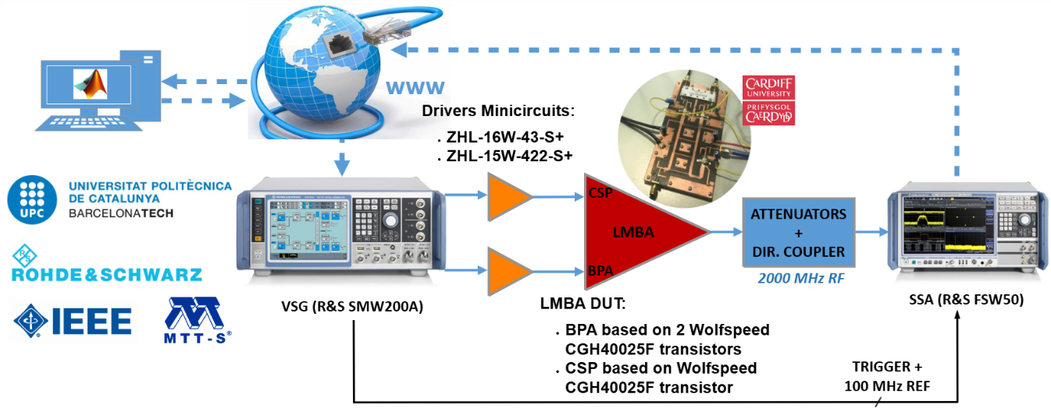

Fig. 1. Block Diagram of the remoteUPCLab.

The participants will be able to access via world wide web (www) the remoteUPCLab, depicted in Fig.1. The remoteUPCLab server receives baseband IQ waveforms from a remote user. These signals are downloaded into the VSG, which generates and upconverts them into two RF signals: one for the balanced input port and another for the control port of the LMBA. The Signal and Spectrum Analyzer (SSA) is in charge of RF down conversion and data acquisition of the waveform at the output of the PA, whose IQ data will be sent back to the remote user for DPD processing.

## Scoring

At each iteration, the DPD linearizer performance will be scored taking into account five different quality metrics:

* The average output power (dBm)
* The PA power efficiency (%)
* The worst channel ACPR value (dB)
* The worst channel EVM value (%)
* The number of coefficients of the DPD function

The out-of-band linearity is measured in terms of the adjacent channel power ratio (ACPR), computed for each band as the difference (in dB) between the integrated in-band power and the highest between the right and left, adjacent, integrated out-of-band powers (within the same bandwidth). The time-domain error is measured as error vector magnitude (EVM) computed as the root mean squared (RMS) value of the error in percentage (%) between the ideal constellation of symbols (being originally generated) and the measured output signals at each band. The number of coefficients of the DPD is represented in real-valued or complex-valued coefficients, accordingly to the DPD function employed by the contestant.

Scoring trends:

* **ACPR Contribution (Weight: 10):** ACPR values below the minimum threshold improve the score, while values above it reduce the score. The minimum ACPR depends on the signal configuration:
  + For 1 or 2 active channels, or the specific case of [0,1,1,1,0]: –45 dB
  + For any configuration with 3 or more active channels: –40 dB
* **EVM Contribution (Weight: 5):** EVM values below the minimum threshold improve the score; values above the minimum threshold decrease it.
* Only considered if the minimum ACPR threshold (–45 dB or –40 dB) is met.
* **Average Output Power (Weight: 10):**  
  Output powers above 30 dBm increase the score, while powers below 30 dBm reduce it.
* Only considered if the minimum ACPR threshold is met.
* **Power Efficiency (Weight: 3):**  
  Contributes positively **only** when the minimum ACPR requirement is satisfied.
* **DPD Model Complexity (Weight: 0.1):**  
  Using fewer coefficients than the threshold improves the score; more coefficients reduce it.
* Complexity thresholds depend on the number of active channels and coefficient type (real or complex):
  + For 1 or 2 channels:
    - Max 50 complex-valued or 200 real-valued coefficients
  + For 3 or more channels:
    - Max 100 complex-valued or 400 real-valued coefficients
* 1 complex coefficient = 4 real coefficients
* This contribution is only considered if the minimum ACPR is met.

The total **SCORE** formula is:

$$SCORE=10⋅\left(ACPR_{min}-ACPR_{worst}\right)+5⋅\left(EVM_{min}-EVM_{worst}\right)⋅α+ \\ + 10⋅\left(P_{out}-P_{min}\right)⋅α+3⋅PA_{efficiency}⋅α+0.1⋅\left(n_{coeffs,max}-n_{coeffs}\right)⋅α$$

with

$$α=\left\{\begin{aligned}1 if ACPR_{min}-ACPR_{worst}&≤0 \\ 0 if ACPR_{min}-ACPR_{worst}>0\end{aligned}\right.$$

where *ACPRmin* is -45 dB if the signal consists of 2 channels, 1 channel or the [0,1,1,1,0] configuration, otherwise -40 dB. Additionally, *ncoeffs,max* is 50 if the DPD function operates with complex-valued coefficients, 200 if these coefficients are real and the signal consists of 2 channels or less. Otherwise, for more than 3 channels, *ncoeffs,max* is 100 if the DPD coefficients are complex-valued or 400 if these are real-valued. Finally, $EVM_{min}=1.5\%$ and $P_{min}=30 dBm$.

On the day of the competition at the IMS venue in San Francisco, the final test will be run three times with different signal configurations (unknown to contestants until the test). Your final SCORE will be the average of these three runs with varying channel configurations.

# Name and number of supporting MTT-S Technical Committee

TC-15 RF/Mixed-Signal Integrated Circuits and Signal Processing Committee

TC-12 Microwave High-Power Techniques Committee

# Additional Awards

Rohde & Schwarz is pleased to include an additional award to the 1st place team.  Through its Technology Academy, R&S has developed a new IEEE-certified online course series called RF Engineering Essentials.

**What's Included?**

* 7 courses covering a range of essential RF and microwave topics
* Unlimited individual access to all course content on-demand 24/7 for 365 days
* IEEE Certificate of Completion
* Time needed to complete: approximately 10.5 hours

**Technical Level**

While no formal prerequisites are required, students will benefit from a basic technical background. The course presents complex RF concepts without heavy mathematical treatment, making it accessible to those with fundamental technical knowledge and a willingness to learn specialized RF terminology and principles.

Rohde & Schwarz will award up to four course vouchers to the 1st place team which provide free access to the course material (valued at $1500 per student).

# Contact information

Prof. Pere L. Gilabert, pere.lluis.gilabert@upc.edu (+34) 934137211

Prof. Gabriel Montoro, gabriel.montoro@upc.edu, (+34) 934137118

Mr. Hermann Boss, hermann.boss@rohde-schwarz.com, (+49) 89412913606