**Speaker Biography: Connected Future Summit 2023**

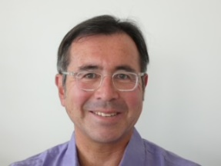**Jim Misener** is Senior Director, Product Management and the Global V2X Ecosystem Lead for Qualcomm and develops and executes Qualcomm’s C-V2X deployment strategy across all global regions. Previously at Qualcomm, Jim led the automotive standards team. Jim was a pioneer in vehicle-highway automation and vehicle safety communication at the California Partners for Advanced Transit and Highways (PATH) at UC Berkeley.  He has served as the PATH Executive Director, Executive Advisor to Booz Allen Hamilton, and as an independent consultant.  In these roles Jim has experience and reputation of delivering dozens of technology projects with large scale safety impact.

In addition to his roles at Qualcomm, Jim serves as a 5GAA board member, ITS America Board

member, ITS California board member, serves on the IEEE ITS Society Board of Governors and is active member of TRB ITS and Vehicle-Highway Automation Committees, where he has led the initial definition for on what could constitute a digital infrastructure. He established and is the

immediate past chair of the SAE C-V2X Technical Committee. Jim also serves as an Advisory

Council member to Mobility 21-Traffic 21 led by Carnegie Melon University. Jim holds BS and

MS degrees from UCLA and USC.

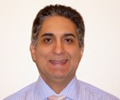 **Ali Sadri** has more than 30 years of scientific and engineering background starting at IBM, Duke University, Intel corporation and the latest as the Chief Technology officer at Airgain.

Dr. Sadri has  demonstrated successful track record of building breakthrough products such as WiGig 60 GHz technology as founder and chairman of the WiGig Alliance , mmWave mesh Backhaul, mmWave and sub-6 GHz Distributed smart repeaters, smart FWA technology and mMIMO antennas. Dr.  Sadri has over 100 issued and pending patents all in wired and wireless communications systems. Ali serves as an international advisor to Tokyo Institute of Technology.

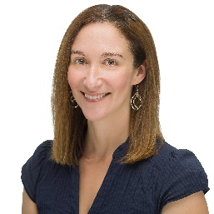**Mari Silbey** is Senior Director of Partnerships and Outreach for US Ignite, and Program Director for the Platforms for Advanced Wireless Research (PAWR) program, a $100 million initiative funded by the National Science Foundation and a consortium of more than 30 wireless companies and associations. Within the PAWR Project Office, Mari is responsible for strategy and oversight across multiple wireless testbeds, as well as coordinating with government agencies and engaging with academic and industry research communities. She has nearly two decades of experience in telecom, including many years as a journalist covering broadband infrastructure. Mari also worked previously in the private sector with companies including Limelight Networks and Motorola before its acquisition (and later sell-off) by Google.

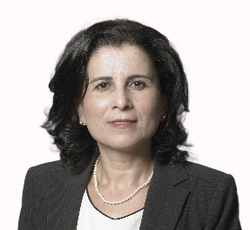**Maha Achour** has more than 25 years’ experience in leadership roles in the semiconductor, wireless optical, mmwave, and RF sensing and communication systems for commercial and defense industries — with both startup and public companies. Recognized for her deep technology background, management, and business development skills, Maha was recently named to Forbes’ “50 Over 50 - Vision” list of women who are successfully running companies and leading movements. Before founding Metawave, she served as co-Founder and CEO of Polyceed-Dyenamics (where she serves now as Chair of the Board), Co-founder and CTO of Rayspan, Director of Advanced Technology at SDRC (Boeing), Director of Advanced Technology at Optical Access, and lead System Engineer at Tiernan Comm where she worked on first broadcast HDTV-over satellite system. She has also led various DARPA projects in advanced wireless MIMO and optical device technologies. A sought-after industry speaker and thought leader, Maha holds a doctorate degree in Physics from Massachusetts Institute of Technology MIT. She has authored more than 35 publications, holds more than 75 granted patents, and has more than 150 pending patent applications.

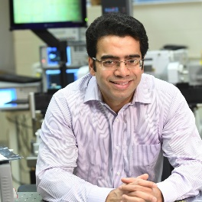**Harish Krishnaswamy** received the B.Tech. degree in electrical engineering from IIT Madras, Chennai, India, in 2001, and the M.S. and Ph.D. degrees in electrical engineering from the University of Southern California (USC), Los Angeles, CA, USA, in 2003 and 2009, respectively. In 2009, he joined the Electrical Engineering Department, Columbia University, New York, NY, USA, where he is currently a Professor and the Director of the Columbia High-Speed and Millimeter-Wave IC Laboratory (CoSMIC). In 2017, he co-founded MixComm Inc., Chatham, NJ, USA, a venture-backed start-up, to commercialize CoSMIC Laboratory’s advanced wireless research. MixComm was acquired in February 2022 by Sivers Semiconductors for $155M, where he is currently Managing Director of the Wireless Business Unit. His research interests include integrated devices, circuits, and systems for a variety of RF, millimeter-wave (mmWave), and sub-mmWave applications.

Dr. Krishnaswamy was a recipient of the IEEE International Solid-State Circuits Conference Lewis Winner Award for Outstanding Paper in 2007, the Best Thesis in Experimental Research Award from the USC Viterbi School of Engineering in 2009, the Defense Advanced Research Projects Agency Young Faculty Award in 2011, the 2014 IBM Faculty Award, the Best Demo Award at the 2017 IEEE ISSCC, the best student paper awards at the 2015, 2018, and 2020 IEEE Radio Frequency Integrated Circuits Symposium and the 2020 IEEE International Microwave Symposium, the 2021 IEEE MTT-S Microwave Magazine Best Paper Award, and the 2019 IEEE MTT-S Outstanding Young Engineer Award. He has been a member of the technical program committee of several conferences, including the IEEE International Solid-State Circuits Conference and the IEEE Radio Frequency Integrated Circuits Symposium. He has also served as a Distinguished Lecturer for the IEEE Solid-State Circuits Society and is a member for the DARPA Microelectronics Exploratory Council.

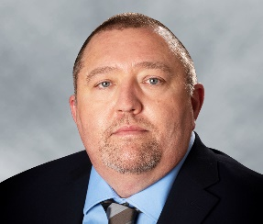**Ryan Jennings** is the VP of SATCOM and Systems with the goal to grow the SATCOM customer base as well as to define and lead the architecture for our future SATCOM products. Ryan brings over 25 years of experience leading mission-critical technology efforts for commercial, intelligence and defense customers.   
Prior to his career at Anokiwave, Ryan held many roles at Ball Aerospace ranging from Principal RF Systems and Antenna Engineer to Senior Manager responsible for Phased Array Systems for High Data Rate communications. Ryan received a B.S. degree in electrical, electronics and communications engineering from the University of Kentucky and an MBA with a focus in executive leadership from Regis University. He holds several phased-array related patents.

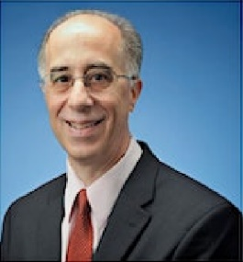

**James Sowers** has 40+ years of experience designing, developing, and manufacturing of RF, microwave, and millimeter-wave microelectronic components for satellite payloads as well as communication and radar systems for commercial and military use.

He is currently Payload Technical Partner for Unit Design Engineering and a Distinguished Engineer at Maxar Space Infrastructure. His responsibilities have encompassed the development of space-qualified, RF active, payload components from C-Band through V-Band including GaN Power Amplifiers, LNA’s, Receivers, Linearized Channel Amplifiers, Local Oscillators and MMICs. Additional responsibilities included Payload Manager for large Ku and Ka Band programs. Joining SS/L in June 1999, he was the Section Manager for Repeater Subsystems Electrical Engineering.

Preceding employment at SS/L, Mr. Sowers was with Lockheed Martin/Martin Marietta/GE Aerospace and was responsible for the research, design, and development of microwave and millimeter-wave MMICs and components for advanced radar and communications systems.

After graduating from Cornell University with a BSEE Jim joined Varian Associates where he was responsible for the research, design, and development of InP Gunn and IMPATT devices and circuits at V and W Bands. Receiving his Master of Science degree from Stanford University he subsequently took a position with Harris Microwave Semiconductor to develop RF/Microwave amplifiers for the military market.

Jim is a Life Senior Member of the IEEE, and has served on the Technical Program and Steering Committee of several IEEE conferences and is a past chair of the IEEE MTT Society -Santa Clara Valley Chapter. Additionally, he maintains an Adjunct Professor position at Santa Clara University.

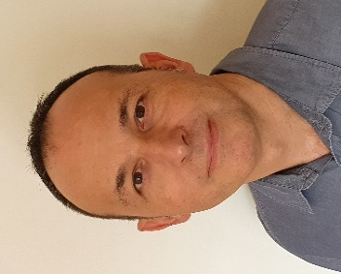**Pascal Chevalier** received the Ph.D. degree in electronics from the University of Lille, France, in 1998 for his work on InP-based HEMT. He joined Alcatel Microelectronics, Belgium, in 1999, where he contributed to the start of RF BiCMOS. Since joining STMicroelectronics, Crolles, France, in 2002, he has been working on the development of SiGe BiCMOS and RF-SOI CMOS technologies and related devices, with a long-lasting research interest in SiGe HBT. He is currently leading the RF-SOI CMOS, BiCMOS & Disruptive Technologies R&D team, and is a Fellow of Technical Staff. Dr. Chevalier has authored or co-authored over 200 technical journal papers and conference publications. He has served the Technical Program Committees of the IEEE Bipolar / BiCMOS Circuits and Technology Meeting (BCTM), the ECS SiGe Symposium, and the IEEE BiCMOS and Compound Semiconductor Integrated Circuits and Technology Symposium (BCICTS). He has been a member of the RF & AMS Technologies section of the ITRS of which he led the Silicon Bipolar & BiCMOS subgroup. He currently serves the Technical Program Committee of the IEEE International Electron Devices Meeting (IEDM).

**Ted Jones** is Sr. Director for Defense and Aerospace Services reporting into the High Performance Analog business unit.  The Services product line includes Foundry, Advanced Packaging, and Extended Foundry Services.  He has experience in both the defense and commercial industries covering RF Systems and Program/Business management.  His product experience includes Sensors, Subsystems, Advanced Packaging, and Manufacturing.   Ted has BSEE degree from University of Colorado and an MSEE degree University of Texas Arlington.

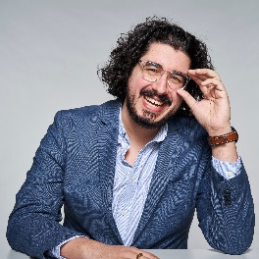

**Ben Coffin** is the 6G Solutions Marketing Manager at Keysight Technologies. Having spent the last decade in the test and measurement industry, Ben has spent his time in business development, product management and systems engineering roles across the wireless communications space, primarily focusing on research testbeds and advanced wireless communications. Ben is enthusiastic about telling the stories about how the technology in the wireless world is advancing and how the bleeding edge finds root through research and industry and academic collaboration. Ben holds a Bachelors in Wireless Engineering from Auburn University.

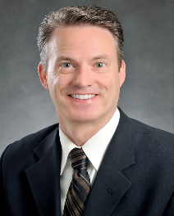**Dennis Lewis** received his BS EE degree with honors from Henry Cogswell College and his MS degree in Physics from the University of Washington.  He has worked at Boeing for 34 years and is recognized as a Technical Fellow, leading the enterprise antenna measurement capability for Boeing Test and Evaluation. Dennis holds eleven patents and is the recipient of the 2013 & 2015 Boeing Special Invention Award.   He is a senior member of the IEEE and several of its technical societies including the Microwave Theory and Techniques Society (MTT-S), the Antennas and Propagation Society and the Electromagnetic Compatibility (EMC) Society.   He actively contributes to these societies as a member of the IEEE MTT-S subcommittee 3 on microwave measurements and as a Board Member and a past Distinguished Lecturer for the EMC Society.  He is a Senior Member and served as Vice President on the Board of Directors for the Antenna Measurements Techniques Association (AMTA) and chaired its annual symposium in 2012 and 2023.  His current technical interests include aerospace applications of reverberation chamber test techniques as well as microwave and antenna measurement systems and uncertainties.