TC Number and name:
TC—3 (RF/Microwave Measurements committee)

Primary contact name(s), email address(es), and phone number(s) of host or competition leader(s):

Debapratim Ghosh
Angela Stelson
Patrick Roblin

Title of the student design competition:
Measurement and extraction of device parameters of an RF transistor

Abstract:
RF transistors (MOSFETs and BJTs) find use in a number of applications including low noise amplifiers, general-purpose amplifiers, power amplifiers, and more. For an RF engineer to reliably work with these transistors, it is essential for them to have knowledge of the small signal model parameters associated with these devices. With this backgrownd, this contest invites students to develop technique(s) to reliably measure and extract several small-signal parameters of an RF transistor. The contest will be judged by how close the measured parameters are to the modelled S-parameters and how reasonable the model parameters extracted are compared to the values provided in the device datasheet given similar bias conditions.

Competition Level and Prizes:
This will be a single-level competition, and is oriented primarily towards senior undergraduate students, graduate students, and doctoral scholars in their first year.

Competition Description and Rules:
The objective of this competition is to develop a technique to measure a bipolar RF transistor with a VNA and extract an equivalent-circuit model.

- You will use any one of these RF transistors-- BFP420, BFP520 or BFP410, from Infineon. You have to use the SOT343 package. Passive components in 1206/0603 packaging may be used.
- You have to develop circuit(s), technique(s) needed to measure and deembed the above small-signal parameters of your chosen transistor. Other associated circuits including biasing, AC/DC decoupling etc. will need to be designed by you as well. The biasing circuit should be designed to bias the device at a stable operating point (w.r.t. temperature). Design the biasing for I_{C} = 20 mA and V_{CE} = 2 V.
- You will need to procure your own transistor (BFP420/BFP520/BFP410) and design, fabricate, and assemble any printed circuit boards (PCBs) as may be necessary for this activity. Effectively, the outlines for your PCB(s) for various measurements may look like as shown in Figure 1.

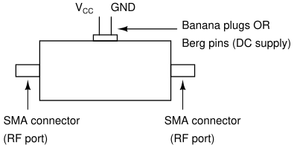
Figure 1: Outline of your PCB(s) for the measurement competition.

- The model accuracy will be evaluated from 1 MHz to 2.5 GHz.
- Each group should develop preferably develop their own extraction algorithm using computer languages such as Matlab, Mathematica or Python. The extraction and modelling will be time limited.
- You will need to simulate the equivalent circuit model with the device model library (SPICE or otherwise!) in a standard simulator such as ADS or AWR. Students may obtain a demo license from Keysight or Cadence, respectively, for the above simulators. Do not use touchstone files (S-parameter data versus frequency, .SNP files) in your simulation of the transistor model itself.
- Your simulation must be shown to the judges during the time of the competition. The S-parameters (to be measured in order to extract the equivalent circuit model parameters) should be also be shown in the simulation during the competition.
- During testing, you can expect to have access to a 2-port VNA, and DC regulated power supplies.
- Each group will be judged with a figure of merit (error), which is defined as follows:

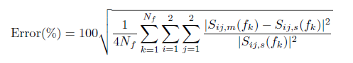
where N_{f} is the number of frequency points, and S_{ij,m} and S_{ij,s} indicate the measured and simulated S-parameters respectively, at the frequency f_{k}.
- In addition, the students should demonstrate the consistency of the extracted model parameters (e.g., collector-base (CB) capacitance, base-emitter (BE) capacitance, base-emitter (BE) forward resistance) with the values of the datasheet.

Presentation:
Each team would need to give a short presentation of about 10 minutes to the judges and the other students before the start of the demonstration.

